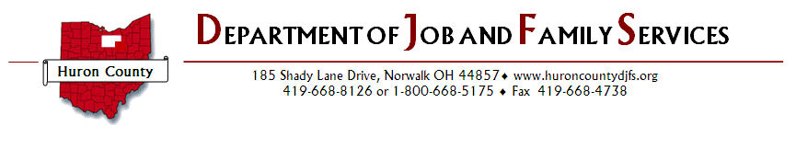
FREE COATS
and
Warm Clothing
Distribution

November 30th, 2021
8:00 a.m. – 4:00 p.m.
Lobby A

Sponsored by BAS Broadcasting Radio 102.7WCPZ - 100.9 WMJK – 1450am WLEC
and Huron County Department of Job and Family Services

